# Mulitdrone Control for Inhouse Flights

## Drones are used in many applications. The objective of the thesis is to develop a control platform for ARDrones and Bebob Drones based on the Roboter Operating System.

The control environment is used to compose drone timelines. The timelines define, how drones act in a multi-drone environment. The environment makes use of the nodesjs environment (ros Library). Gazebo is used as 3D simulation tool (TUM Simulator).

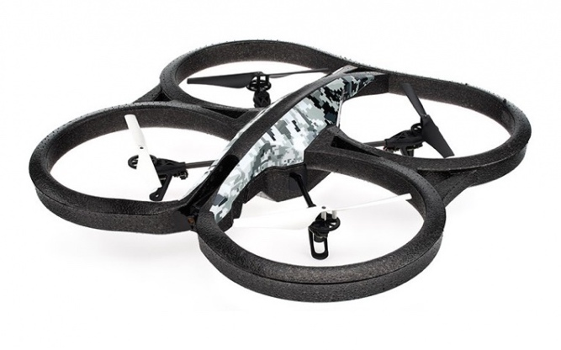

The hardware drones are controlled using the autonomy driver.

Contents:

* Introduction to ROS
* Setup the development environment
* Control drone using the environment
* Setup multi-drone environment
* Comparison of simulation and real drone
* Optimization of control using feedback or control mechanisms

Objective of the thesis is to optimize version 1.0 of the control environment.